## 实验六 综合练习一

**实验内容**

1. 使用tkinter库编写GUI版本的猜数游戏。每次猜数之前要启动游戏并设置猜数范围和最大猜数次数等参数，退出游戏时显示战绩（共玩了几次，猜对几次）信息。

|  |
| --- |
| import tkinter as tk  import sys  import random  import re  number = random.randint(0,1024)  running = True  num = 0  nmaxn = 1024  nminn = 0  def eBtnClose(event):  root.destroy()  def eBtnGuess(event):  global num  global nmaxn  global nminn  global running  if running:  val_a = int(entry_a.get())  if val_a == number:  labelqval("恭喜你答对了！")  num+=1  running = False  numGuess()  elif val_a < number:  if val_a > nminn:  nminn = val_a  num +=1  labelqval("小了哦，请输入"+str(nminn)+"到"+str(nmaxn)+"之间任意的整数:")  else :  if val_a<nmaxn:  nmaxn = val_a  num +=1  labelqval("大了  哦，请输入"+str(nminn)+"到"+str(nmaxn)+"之间任意的整数:")  else :labelqval("你已经猜对了!")  def numGuess():  if num ==1:  labelqval("哇,一次答对!")  elif num<10:  labelqval("十次之内就成功了！尝试次数:"+str(num))  else :  labelqval("很遗憾，虽超过10次，不过还是猜对了！恭喜！"+str(num))  def labelqval(vText):  label_val_q.config(label_val_q,text=vText)    root = tk.Tk(className = "猜数字游戏")  root.geometry("400x90+200+200")  label_val_q = tk.Label(root,width= "80")  label_val_q.pack(side = "top")  entry_a = tk.Entry(root,width="40")  btnGuess = tk.Button(root,text="猜")  entry_a.pack(side = "left")  entry_a.bind('<Return>',eBtnGuess)  btnGuess.bind("<Button-1>",eBtnGuess)  btnGuess.pack(side="left")  btnClose = tk.Button(root,text="关闭")  btnClose.pack(side = 'left')  btnClose.bind("<Button-1>",eBtnClose)  labelqval("请输入0~1024之间的任意整数:")  entry_a.focus_set()  print(number)  root.mainloop() |

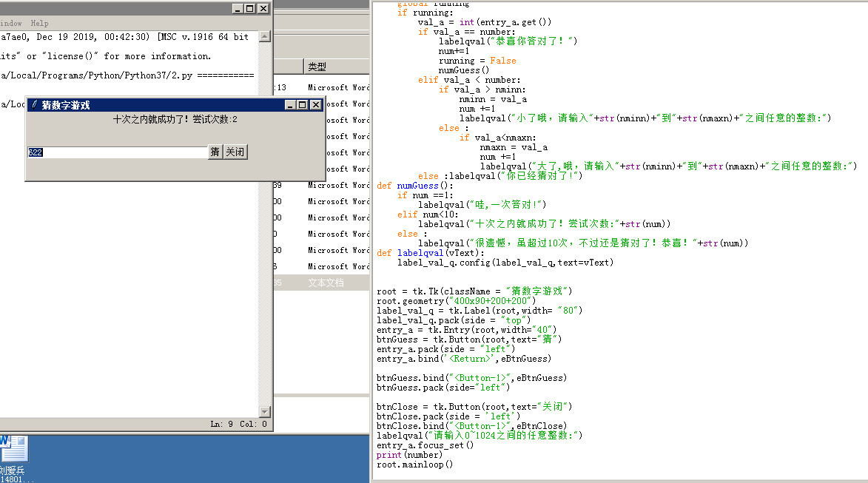

1. 小学口算题生成器。在小学一二年级，只能口算20以内整数的加减法，三四年级可以口算超过20的整数四则运算，五六年级可以口算带括号的式子。编写程序，批量生成小学口算题，要求把生成的口算题写入文件中。用户指定生成题目数、题目适用年级。

|  |
| --- |
| # -*-codeing = utf-8 -*-  # @Time : 2021/7/2 10:10  # @Author ：kklab  # @File : 小学计算器.py  # @Software : PyCharm  import random as ra  op = open("题目.txt", "w")  def otgrade(number):  n = 1  while n <= number:  num1 = ra.randint(0,20)  num2 = ra.randint(0,20)  k = ra.randint(0,2)  if k==1:  mark = "+"  else:  mark = "-"  n = n + 1  shizi = str(num1) + mark + str(num2) + "="  print(shizi)  op.write(shizi +"\n")  op.close()  def tfgrade(number):  n = 1  while n <= number:  num = ra.randint(20, 100)  shizi = str(num)  i = 0  while i < 3:  num = ra.randint(20, 100)  k = ra.randint(0,4)  if k==1:  mark = "+"  elif k==2:  mark = "-"  elif k==3:  mark = "*"  else:  mark = "/"  i = i + 1  shizi = shizi + mark + str(num)  n = n + 1  shizi = shizi + "="  print(shizi)  op.write(shizi +"\n")  op.close()  def fsgrade(number):  n = 1  while n <= number:  num = ra.randint(20, 100)  shizi = str(num)  i = 0  while i < 3:  num = ra.randint(20, 100)  k = ra.randint(0,4)  if k==1:  mark = "+"  elif k==2:  mark = "-"  elif k==3:  mark = "*"  else:  mark = "/"  if mark == "+" or mark == "-":  shizi = "(" + shizi + mark + str(num) + ")"  else:  shizi = shizi + mark + str(num)  i = i + 1  n = n + 1  shizi = shizi + "="  print(shizi)  op.write(shizi +"\n")  op.close()  i = 1  select = int(input("请输入选择（1.一二年级 2.三四年级 3.五六年级）："))  number = int(input("输入生成题目:"))  while i<2:  if select == 1:  otgrade(number)  elif select == 2:  tfgrade(number)  elif select == 3:  fsgrade(number)  else :  print("输入有误，请重新输入!")  select = int(input("输入题目适用年级（1.一二年级 2.三四年级 3.五六年级）："))  number = int(input("输入生成题目:")) |

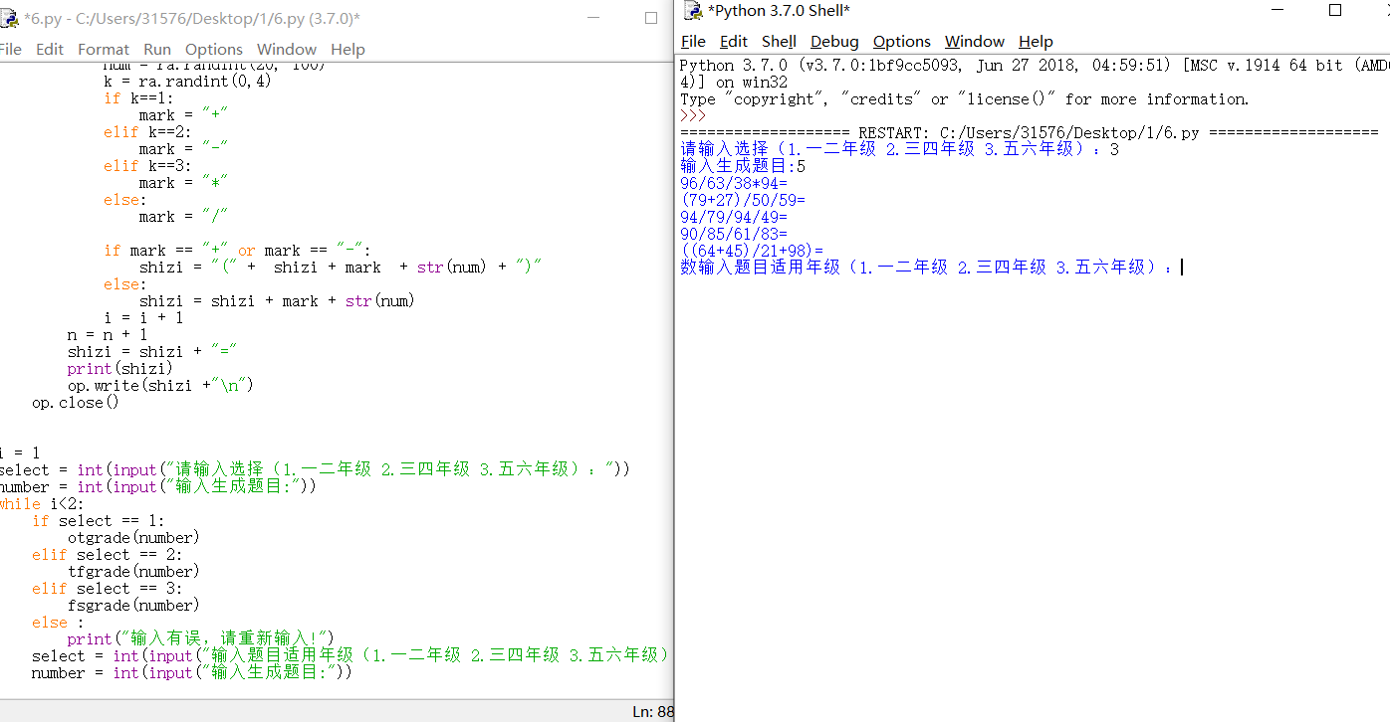

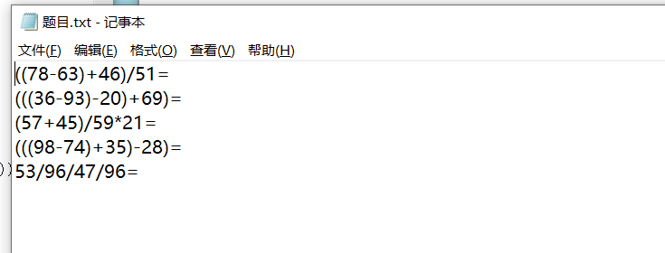

**（三）实验结果**

要求提交word文档，文档命名规则：姓名+学号+实验次数.doc

内容包含：

* 实验题目
* 源代码
* 运行结果截屏